PLUGINS SWEETALERT

- Utilizar plugins de Jquery para mostrar mensajes.

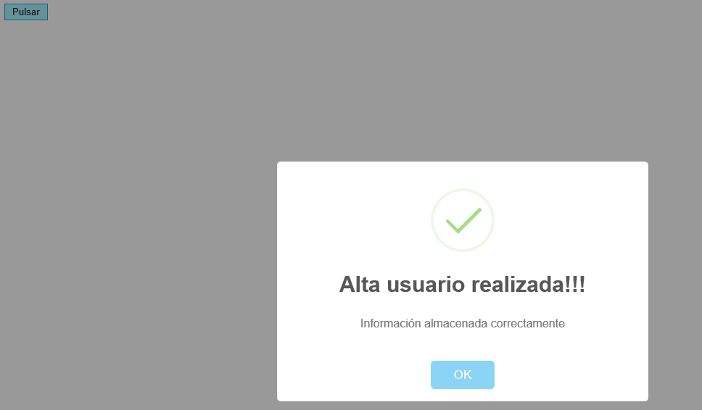

<!DOCTYPE html>
<html>
<head>
<meta http-equiv="Content-Type" content="text/html; charset=utf-8" />
<title></title>
<link href="css/sweetalert.css" rel="stylesheet" />
<script src="js/jquery-1.12.3.min.js"></script>
<script src="css/sweetalert.min.js"></script>
<script src="css/sweetalert-dev.js"></script>

<script>
$(document).ready(function () {
$("#boton1").click(function () {
swal("Alta usuario realizada!!!", "Información almacenada correctamente", "success"); //success, error,warning,…
});
});
</script>
</head><body>

<input type="button" id="boton1" value="Pulsar">
</body>
</html>
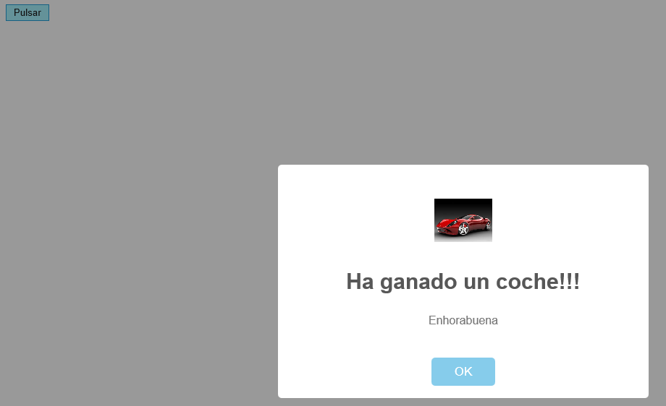

<!DOCTYPE html>
<html>
<head>
<meta http-equiv="Content-Type" content="text/html; charset=utf-8" />
<title></title>
<link href="css/sweetalert.css" rel="stylesheet" />
<script src="js/jquery-1.12.3.min.js"></script>
<script src="css/sweetalert.min.js"></script>
<script src="css/sweetalert-dev.js"></script>

<script>
$(document).ready(function () {
$("#boton1").click(function () {
swal({
title: "Ha ganado un coche!!!",
text: "Enhorabuena",
imageUrl: "images/coche2.jpg"
});
});
});
</script>
</head><body>

<input type="button" id="boton1" value="Pulsar">
</body>
</html>

